**Overview Of IT Industries**

1) What is Program?

A set of instructions that you give to a computer so that it will do a particular task.

2) What Is Programming?

To Create a Program. Plan for something to happen at a particular time.

3) Which Types of Programming Languages?

Procedural Programming

Ex: C Language

Object Oriented Programming

Ex: C++ Language

Logical Programming

Ex: Prolog Language

Functional Programming

Ex: Python, Java Etc…

4) What Is WWW?

- Known as a World Wide Web

- Is a collection of websites or web pages stored in web servers.

- Connected to local computers through the internet.

- Websites contains text pages, images, videos, audios, etc.

- Users can access the content of these sites from any part of the world over the internet using their devices such as computers, laptops, cell phones etc.

5) How Internet Works?

- A server is where websites are stored, and it works a lot like your computer’s hard drive.

- Computers connect to each other and to the Internet via wires, cables, radio waves, and other types of networking infrastructure. All data sent over the Internet is translated into pulses of light or electricity, also called "bits," and then interpreted by the receiving computer.

6) What is Client and Servers?

- Client-server is a relationship in which one program, the client, requests a service or resource from another program, the server.

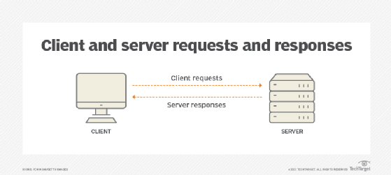

7) Types of Internet Connections?

- Digital Subscriber Line (DSL)

- Cable Internet

- Fiber Optic

- Satellite Internet

- Wireless

- Broadband over Power Lines (BPL)

8) What Are Protocols?

- Protocol is a set of rules for formatting and processing data. Network protocols are like a common language for computers.

- Common Internet protocols include TCP/IP (Transmission Control Protocol/Internet Protocol), UDP/IP (User Datagram Protocol/Internet Protocol), HTTP (Hyper Text Transfer Protocol) and FTP (File Transfer Protocol).